1. Create a new project on GCP

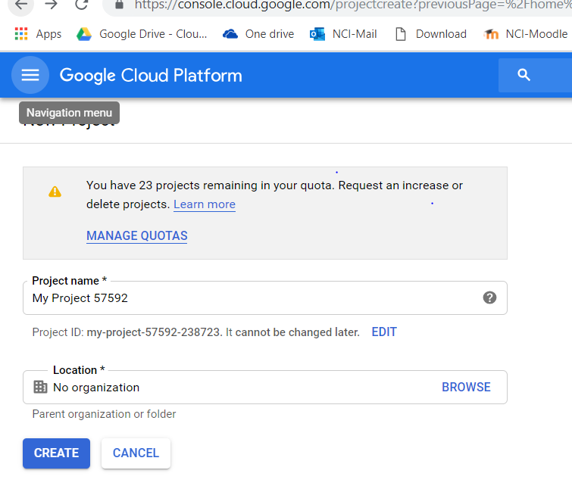

Project created

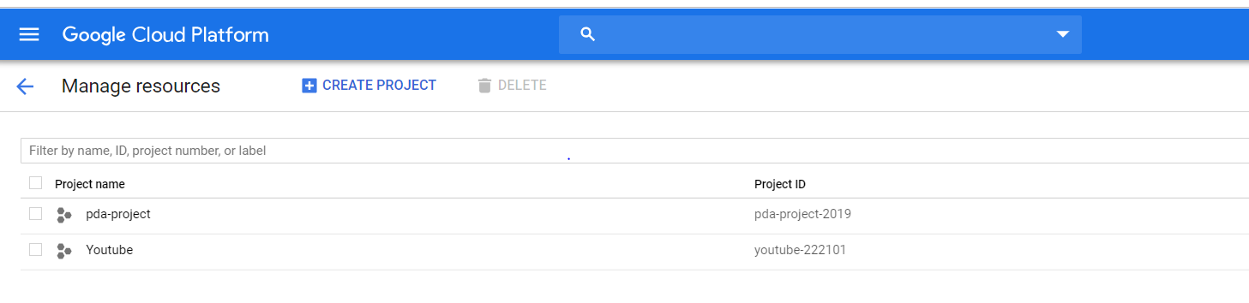

1. Project dashboard

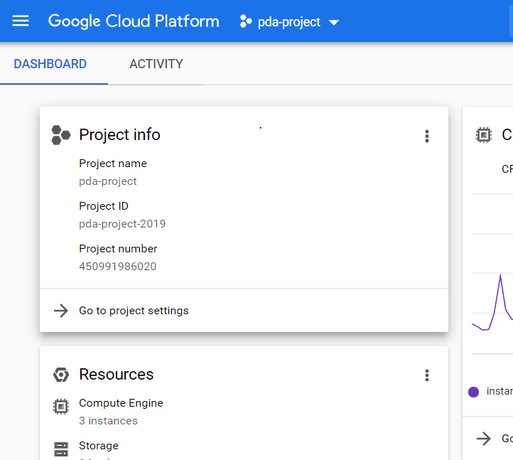

1. Enable billing for the project

Link bank account and enable billing (already done so can’t show in screenshot)

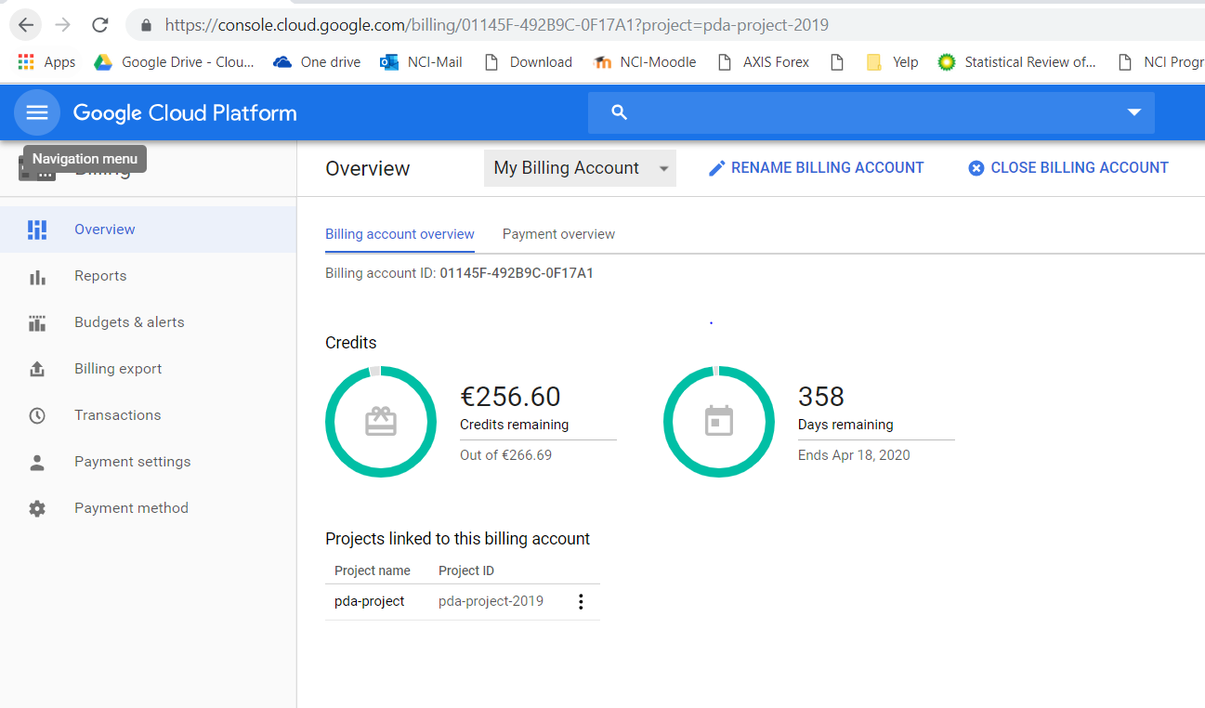

1. Creating cluster on google dataproc

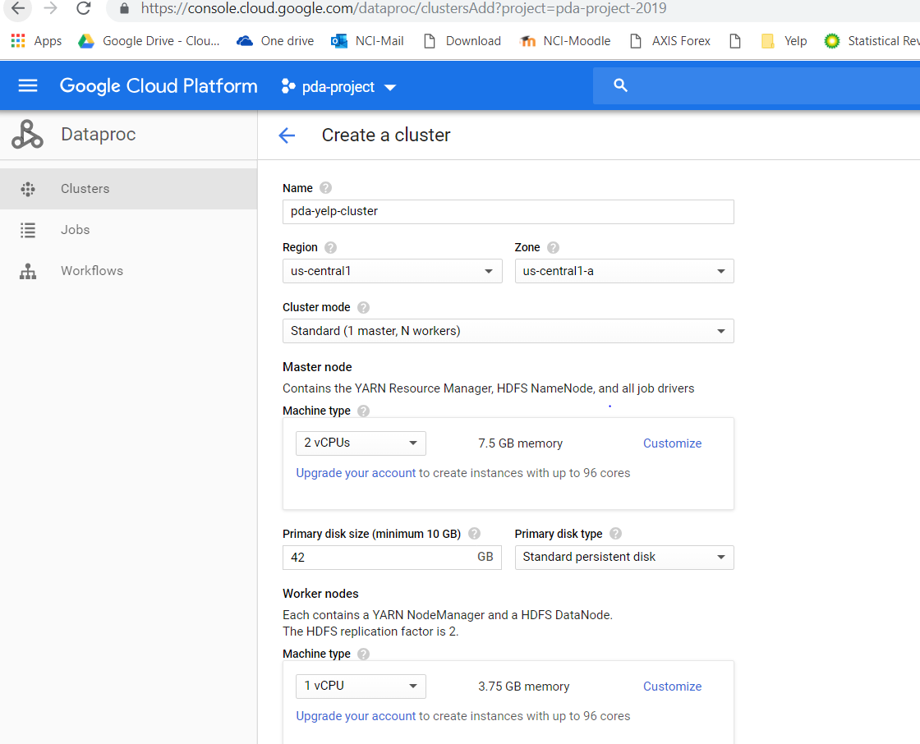

Jyupter and anaconda for pyspark

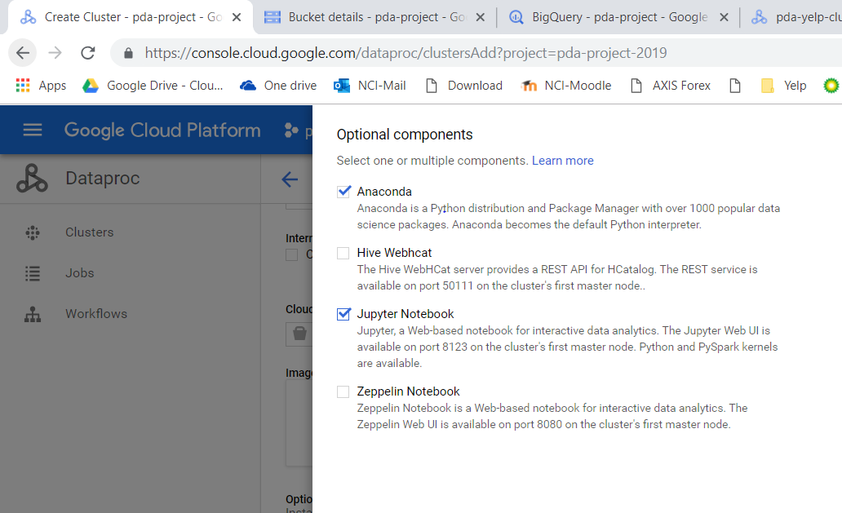

1. Cluster created

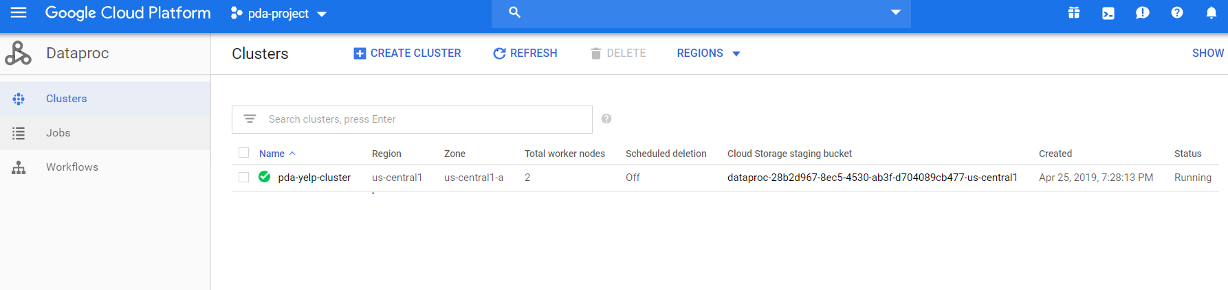

1. SSH to VM instance

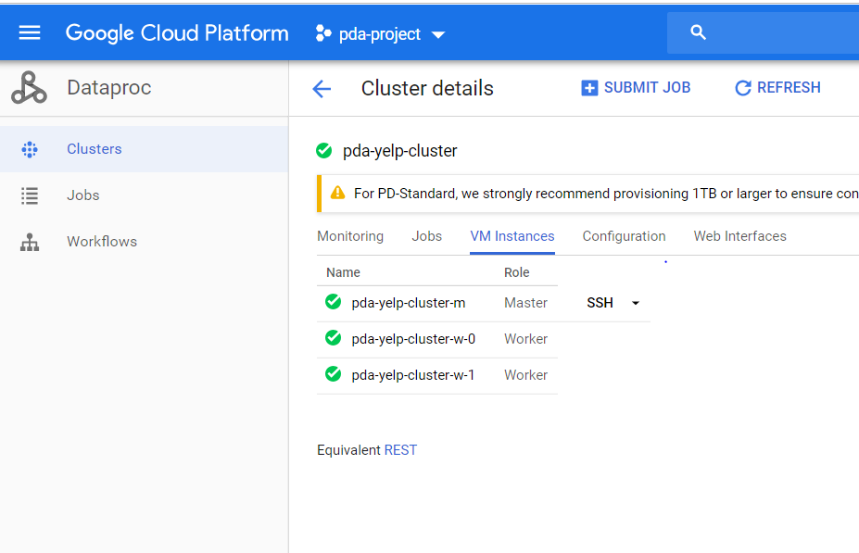

1. Connected to cluster through command line

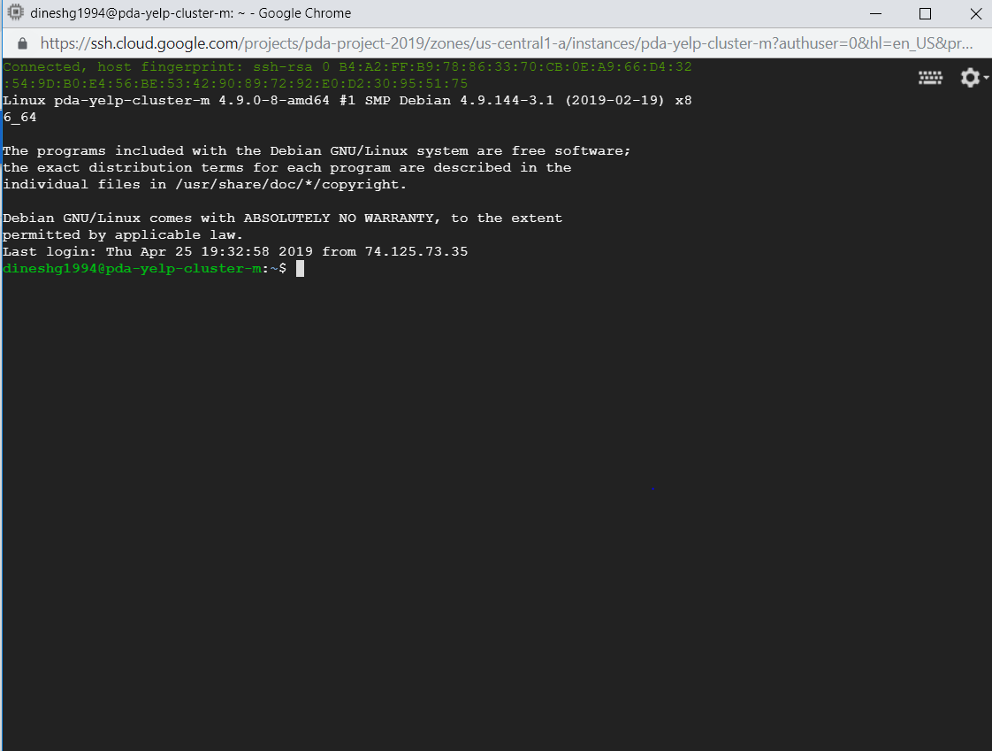

1. Creating bucket in google file system

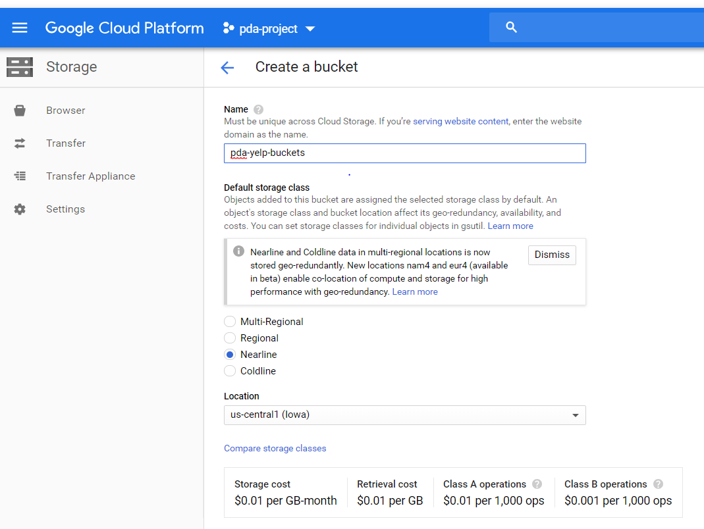

1. Bucket created

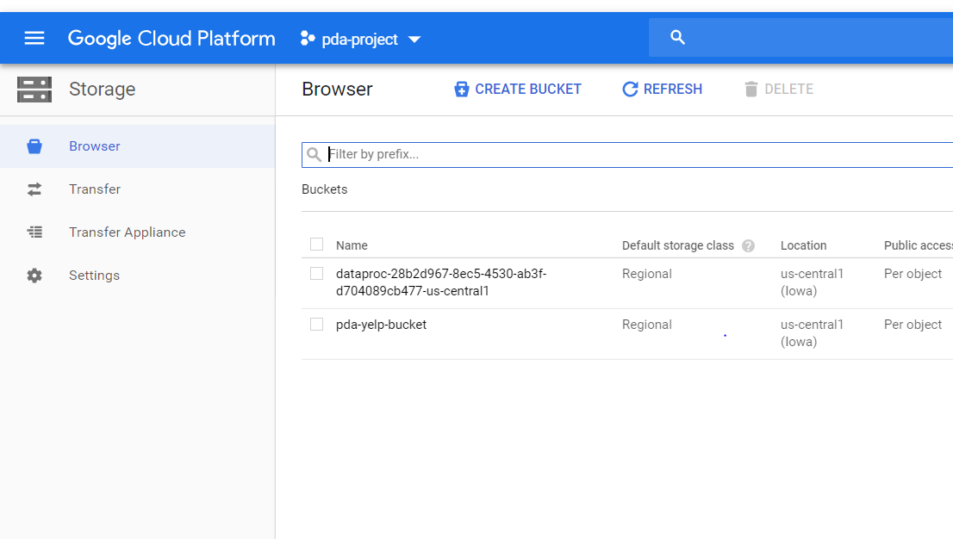

1. Create folders

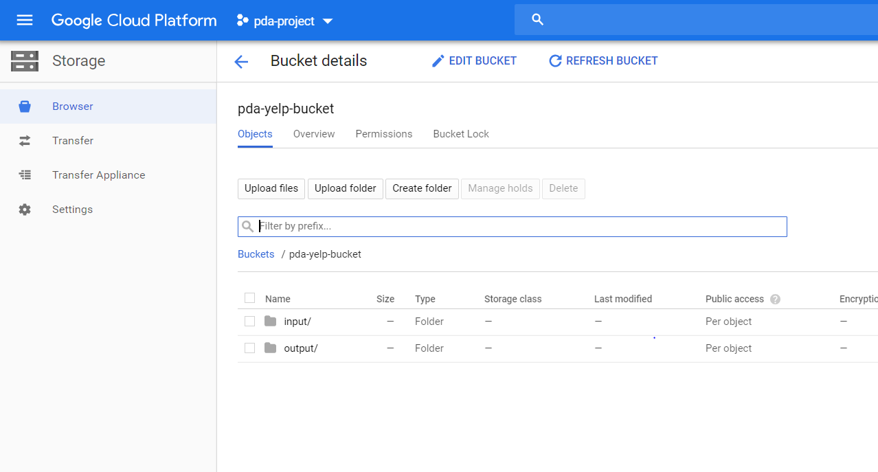

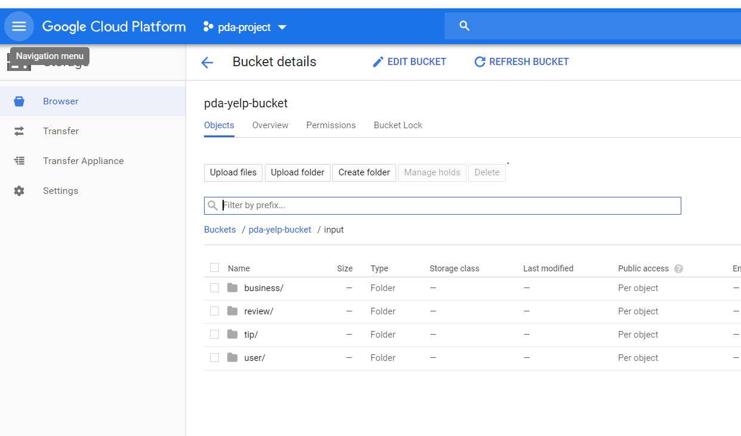

1. File uploaded for respective tasks shown in respective task’s document.

One example of file upload is shown below